**Azure POC (Azure Data Factory)**

|  |  |  |  |  |
| --- | --- | --- | --- | --- |
| Id | Mobile | Laptop | TV | Watch |
| 1  2  3 | 20000 | 50000 | 49999 | 1999  2499 |

Scenario – We have some data available in storage account from external sources. Transform the Data from multiple rows to single rows and store it into separate storage account.

|  |  |  |
| --- | --- | --- |
| Id | Product | Sales |
| 1  1  2  2  3 | Mobile  Watch  Laptop  Watch  TV | 20000  1999  50000  2499  49999 |

1. Create a input and output Blob container (storage account).

Here we are using adfpoc1.csv file for the required data transformation.

1. Create a Data Flow , Dataset and Linked service for the Input File.

1. Select Pivot for row column transformation.

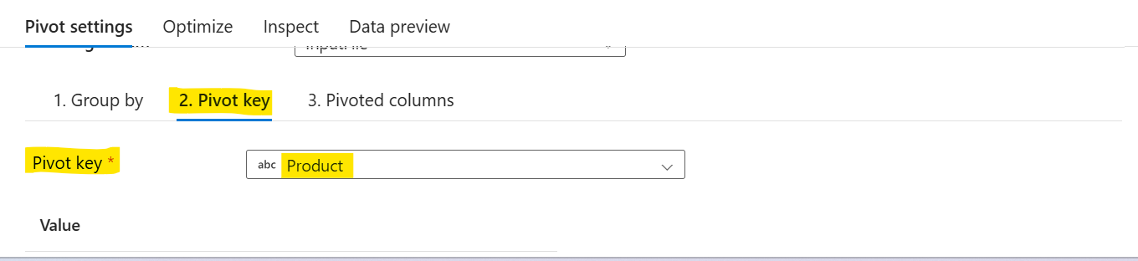

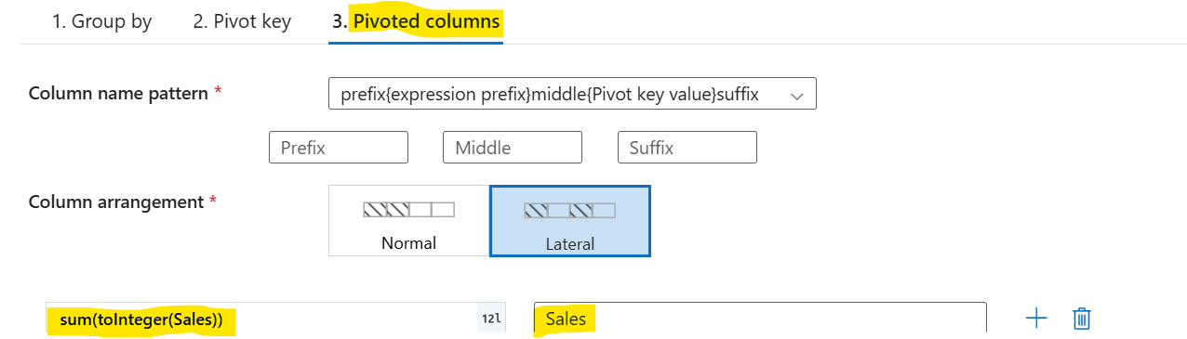

1. Turn on Data flow debug to check if you are getting correct output or not below Publishing into production.

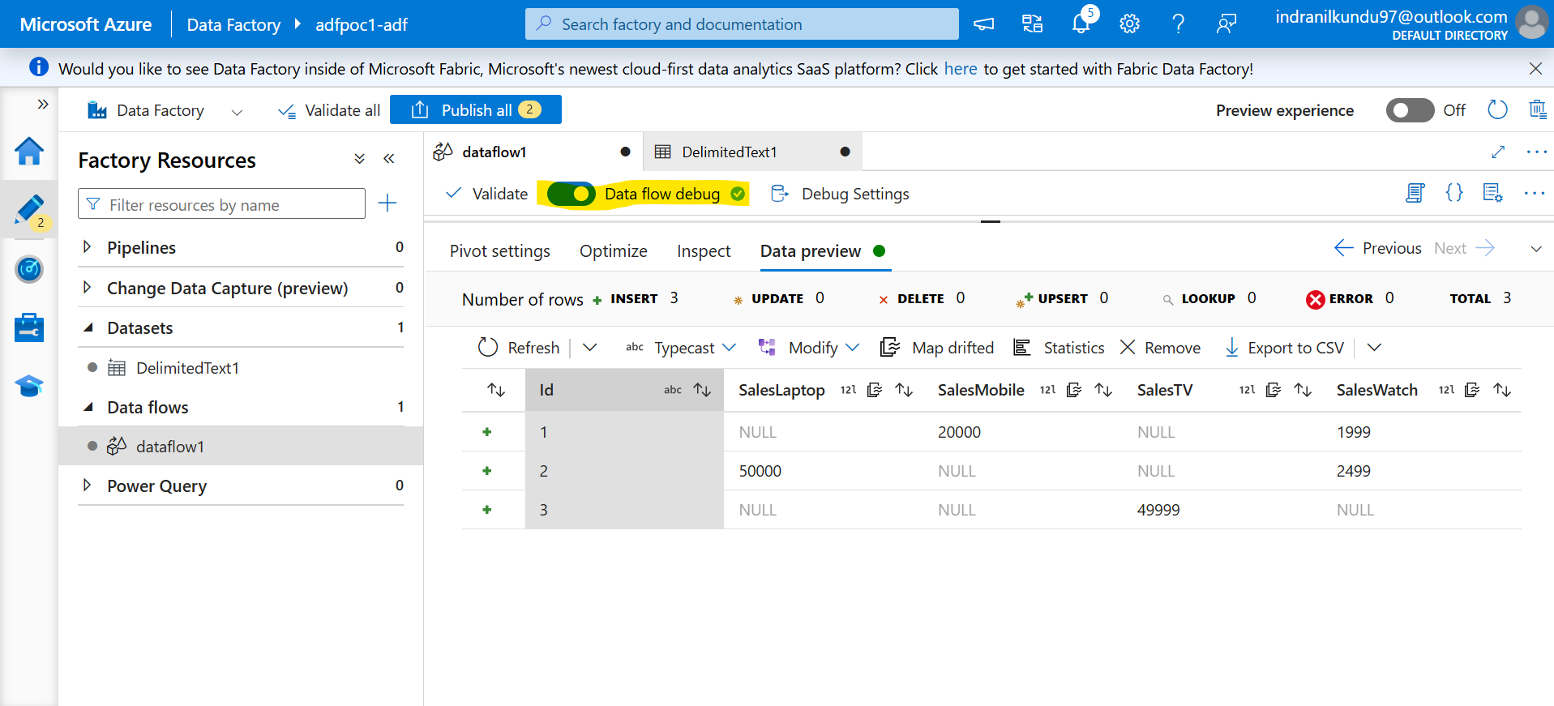

1. Select Sink and set Dataset and select target output folder to store transformed data.

Select Single partition in Optimize to make a single output file.

1. Create a Pipeline -> drag & drop the Data flow -> Validated all -> Publish all -> Add trigger to start the pipeline.

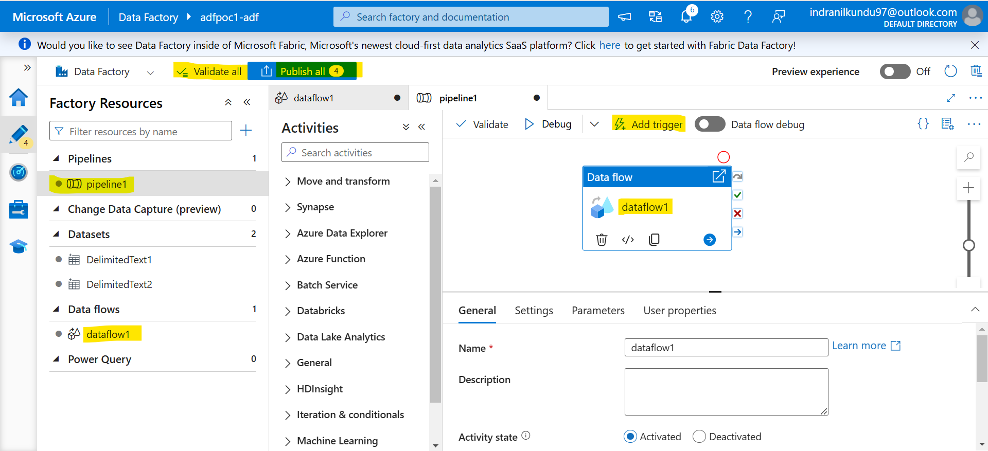

1. After triggering the pipeline go to Monitor tab to check the pipeline run status.

1. Check the Output blob storage for transformed data.



